Cardiovascular Diseases
Student’s Name
Institution Affiliation

Along with the National Heart Lung and Blood Institute, a Cardiovascular disease is a group of conditions that affect the heart and/or blood vessels. The most common forms of cardiovascular disease are coronary artery disease, peripheral vascular disease, and cerebrovascular disease, also known as stroke. Risk factors such as obesity, inactivity, smoking, high blood pressure, high blood cholesterol, diabetes, and family history increase your chances of developing cardiovascular disease (Hajar, 2017).
Cardiovascular disease is one of the leading causes of death and disability in the United States. It is a leading cause of death, responsible for 33% of all deaths. According to the National Center for Health Statistics, more than 1.8 million Americans die each year from cardiovascular disease— more than lung cancer and breast cancer combined. Heart attack results in 500,000 deaths annually and one in every four American adults has high blood pressure. Prevention of disease and promotion of health is critical for reducing death, disability, and health care costs associated with cardiovascular disease. Primary prevention activities such as education on diet, cholesterol reduction, smoking cessation, and exercise reduce the risk for cardiovascular disease (Roth et al, 2018).
According to the American Heart Association: Rarely do people have an identifiable cause or single cause for their heart disease. More than 100 factors are known to contribute to the development of heart disease. The risk of heart disease can be reduced by making changes in the environment, human behavior, and social norms. For some individuals, the factors that lead to heart disease are within their control. Many people can prevent or reduce their risk by making lifestyle changes and taking medications prescribed by their physicians.
The World Health Organization (WHO) has set a goal of reducing the global death rate from ischemic heart disease by 25% by 2020. An effective way to reduce the risk of cardiovascular disease is to encourage people to maintain healthy lifestyles in order to promote health and prevent disease. Healthy lifestyle comprises a balanced diet, regular physical activity, regular blood pressure checks, and screening for diseases such as diabetes and high blood cholesterol at least every 12 months.
The American Heart Association has also set five primary prevention goals: As stated by the American Heart Association, a healthy diet includes eating more fruits, vegetables, and whole grains. A healthy diet is one that includes a variety of foods from all food groups and reduces intake of fats, trans fats, saturated fat, cholesterol, sodium, and refined carbohydrates. Consume less than 10% of calories per day from added sugars. The average American eats 19% of calories from added sugars (Roth et al., 2018). Pay attention to the food you eat and drink. Avoid foods that contain trans fats such as margarine, shortening, and most products marketed as "low fat." Control your weight by exercising regularly. Weight control reduces the risk for heart disease and stroke in both men and women. If you are at high risk for heart disease or stroke, make changes in the environment, human behavior, and social norms to decrease your chances of developing cardiovascular disease. Ideally, prevent cardiovascular disease by quitting smoking, maintaining a healthy weight, controlling your cholesterol level and blood pressure, and eating a healthy diet.
My friend Jane (not her real name) is a thirty-eight-year-old African American female who has been a smoker for the last ten years. She is very obese, has high blood pressure and high cholesterol. Physically, she is in good health except for her high blood pressure and high cholesterol which are major risk factors for cardiovascular disease. Jane is aware of her smoking status and has made the decision to quit smoking one and a half years ago. She has been trying to quit smoking with a combination of nicotine patches, nicotine gum, and counseling. She has not found success in quitting smoking on her own.
Jane is married with two children, an eight-year-old daughter and a six-year-old son. Her husband is very supportive and encourages her to maintain a healthy lifestyle by quitting smoking. Her family history of cardiovascular disease is negative except for her father Mr. Jones who lost his life from myocardial infarction seven years ago. She has a sister who has high cholesterol and has been experiencing shortness of breath due to coronary artery disease.
Jane has a family history of high blood pressure and high cholesterol. She was born with a family history of obesity since both of her parents, her sister, and herself are obese. Jane's physical activity level is low and she does not have any daily exercise regime, which can increase the risk factor for developing cardiovascular disease. Her diets consist of fast meals with little nutritional value on a regular basis. She has a family history of early onset of cardiovascular disease, which is her father who passed away due to sudden cardiac death (myocardial infarction). Jane started smoking when she was nineteen years old. In addition, Jane's high blood pressure and high cholesterol put her at risk for a heart attack. The following teaching material can be used to teach Jane on some primary preventive measures for cardiovascular diseases.
Teaching Material
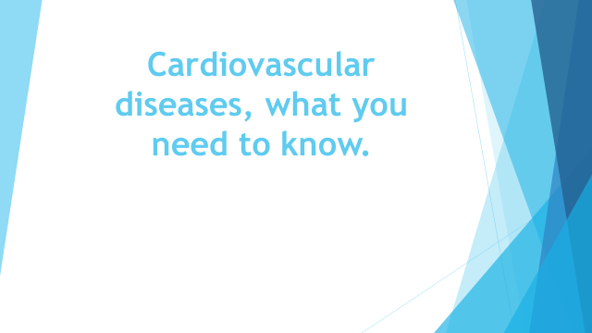

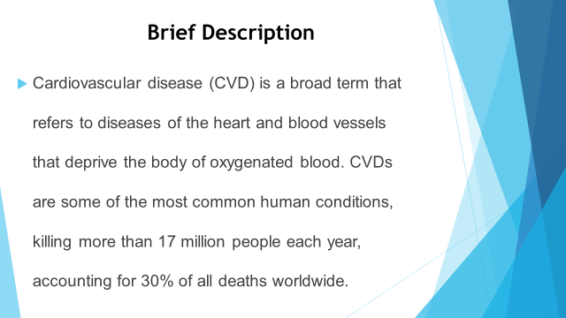
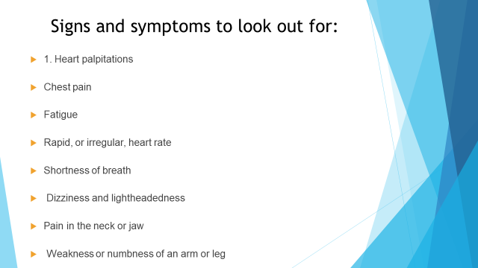

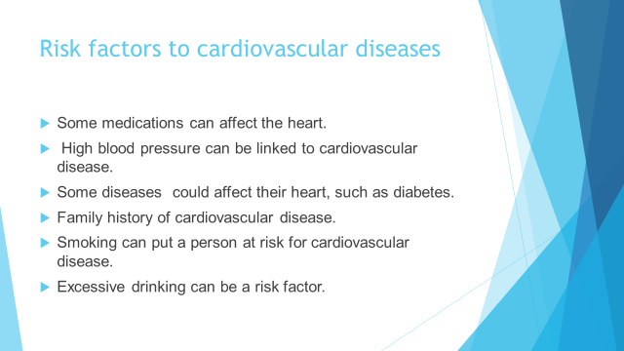

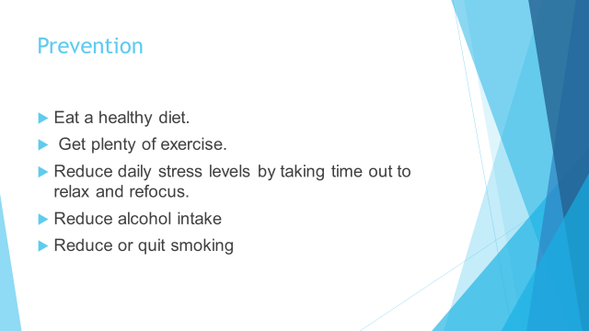



References
Hajar, R. (2017). Risk factors for coronary artery disease: historical perspectives. Heart views: the official journal of the Gulf Heart Association, 18(3), 109.
Roth, G. A., Johnson, C. O., Abate, K. H., Abd-Allah, F., Ahmed, M., Alam, K., ... & Global Burden of Cardiovascular Diseases Collaboration. (2018). The burden of cardiovascular diseases among US states, 1990-2016. JAMA cardiology, 3(5), 375-389.

